**Software Engineering Tools Lab**

**Assignment No-8**

**(Module 5- Software testing using tools)**

**Q 1. What are the prerequisites for installing the TestLink tool.**

* Testlink requires these programs:

1. MySQL 4.0.x

2. php 4.3.x

3. Webserver (Apache 1.3.x or 2.0.x and higher, IIS 3 and higher, etc.)

**Q 2. Install TestLink tool on your machine (Provide screen shots for successful installation and login)**

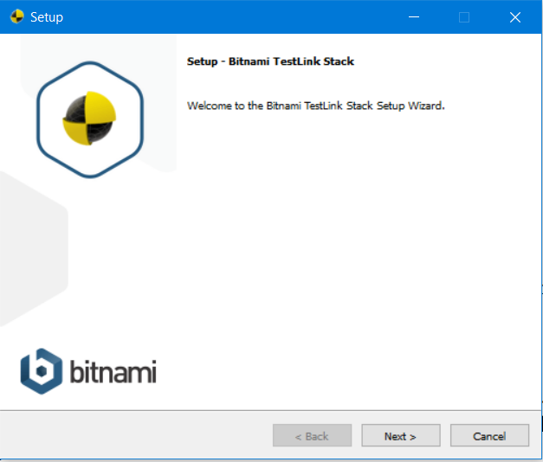

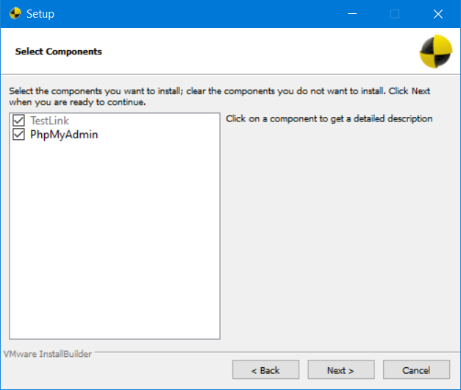

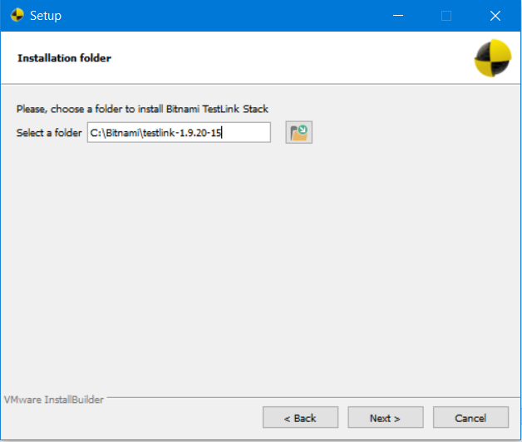

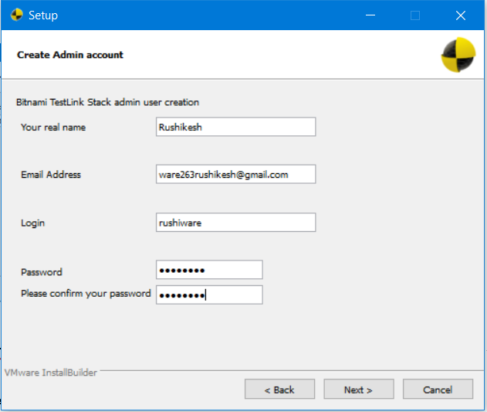

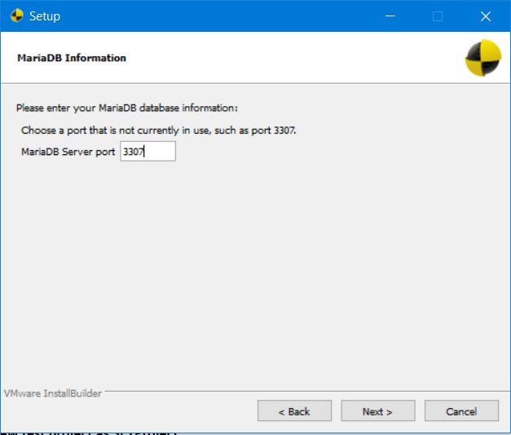

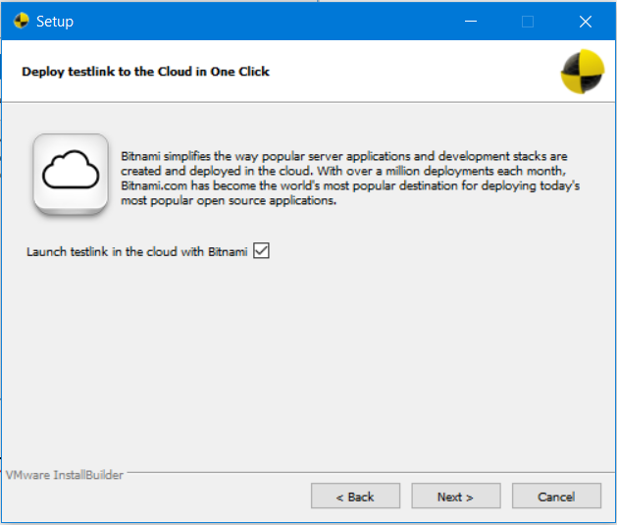

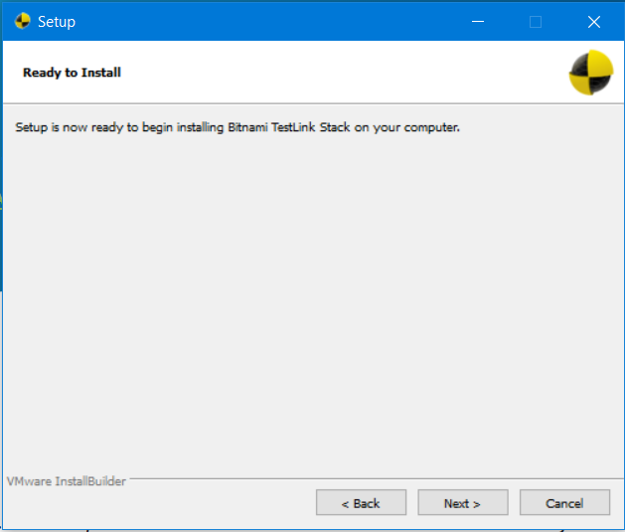



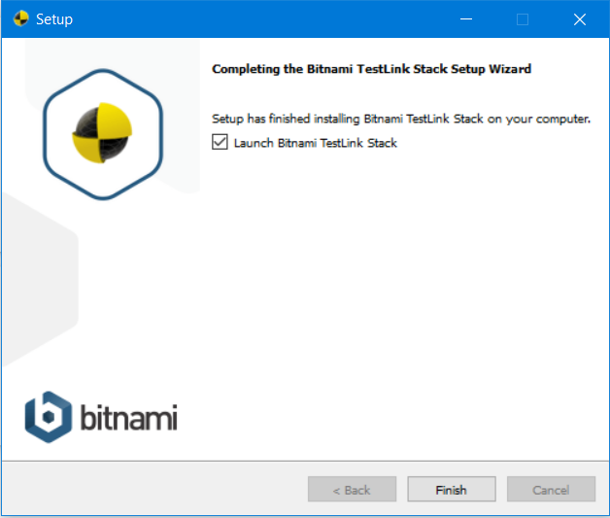

Visit: <http://localhost/testlink/login.php>

And login with your credentials.

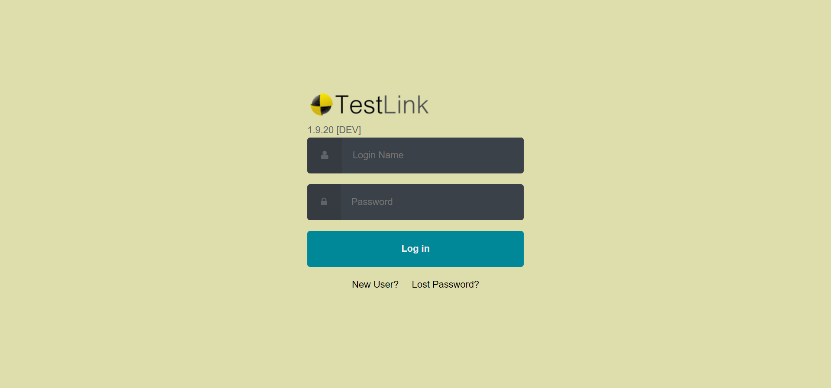

**Q 3. Using TestLink tool create multiple test cases (at least 10) on any application/project that you have implemented.**

**Perform below tasks**

**a. Create New test project as SETProject**

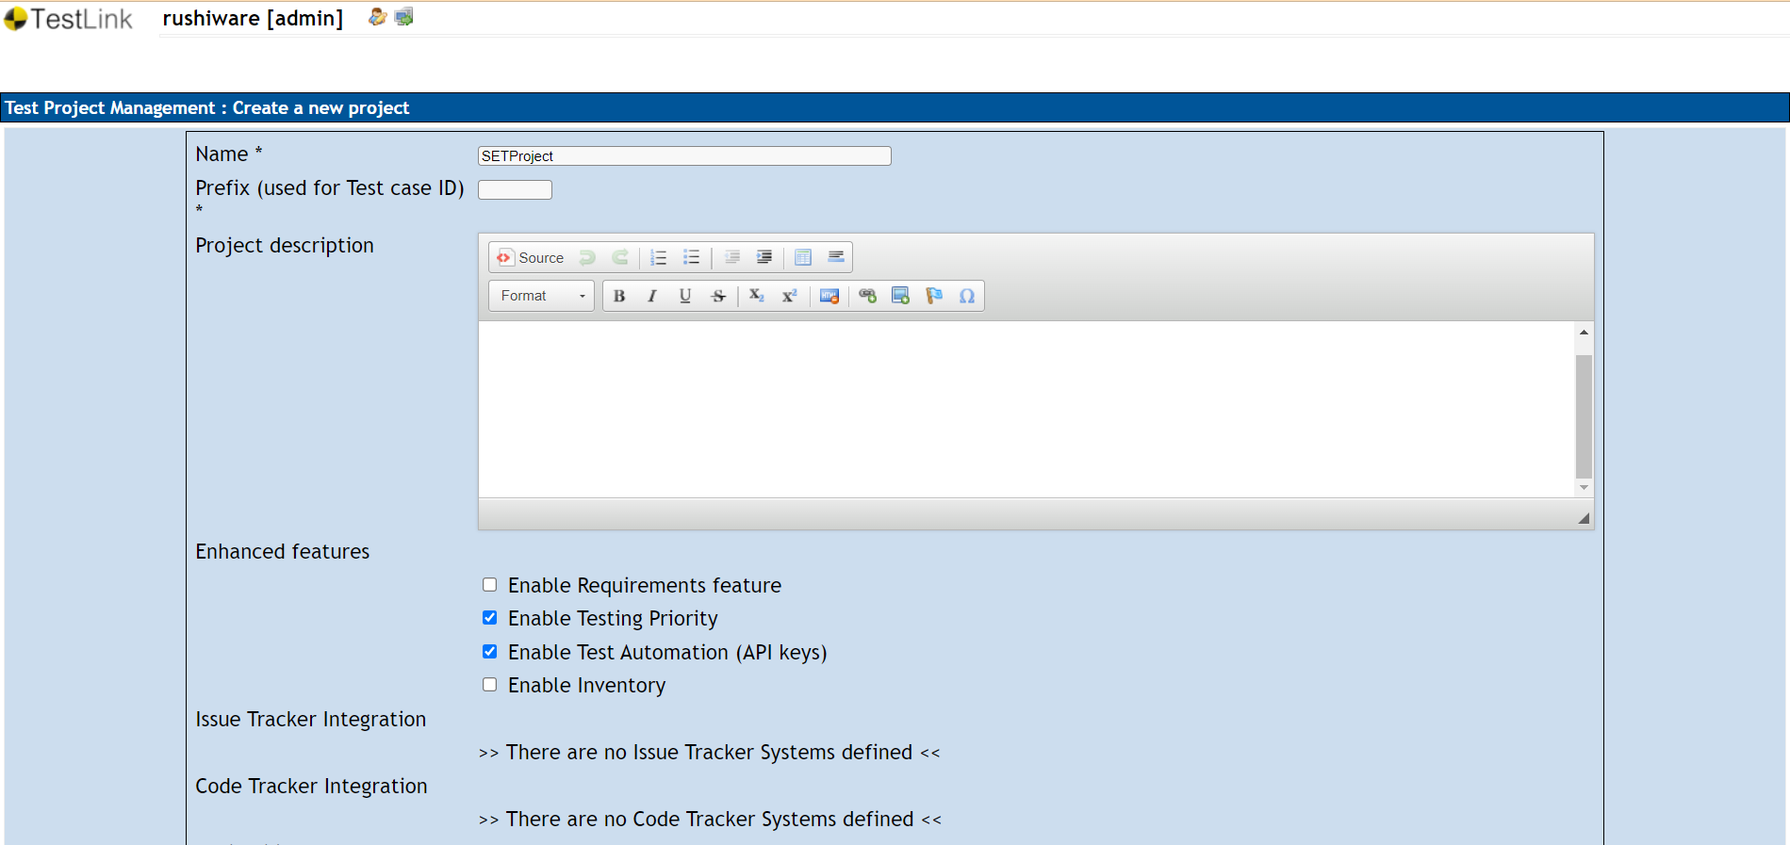

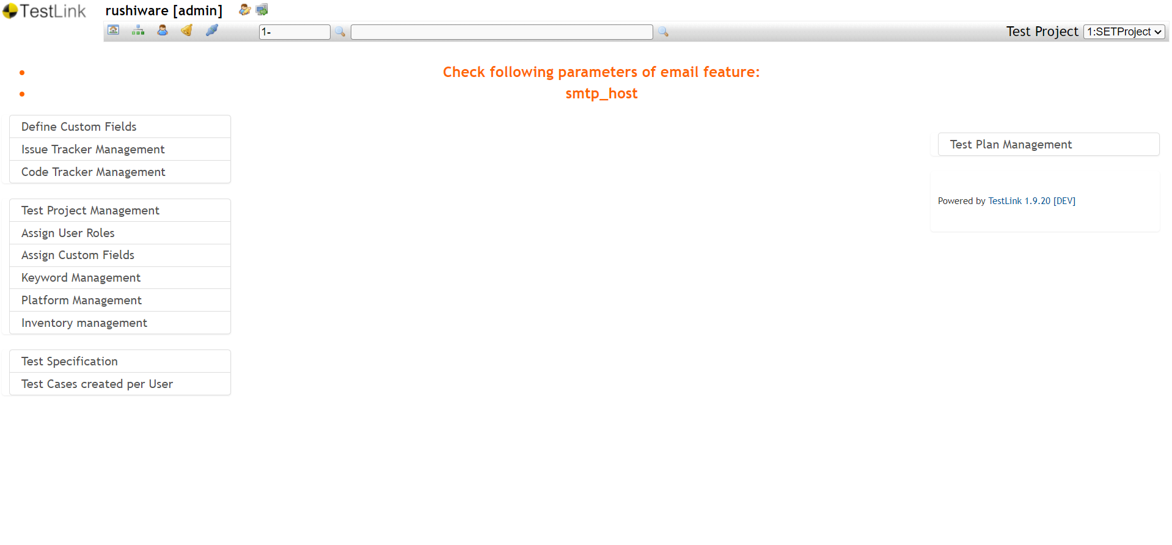

**b. Create a test plan as SETProjectTestPlan**

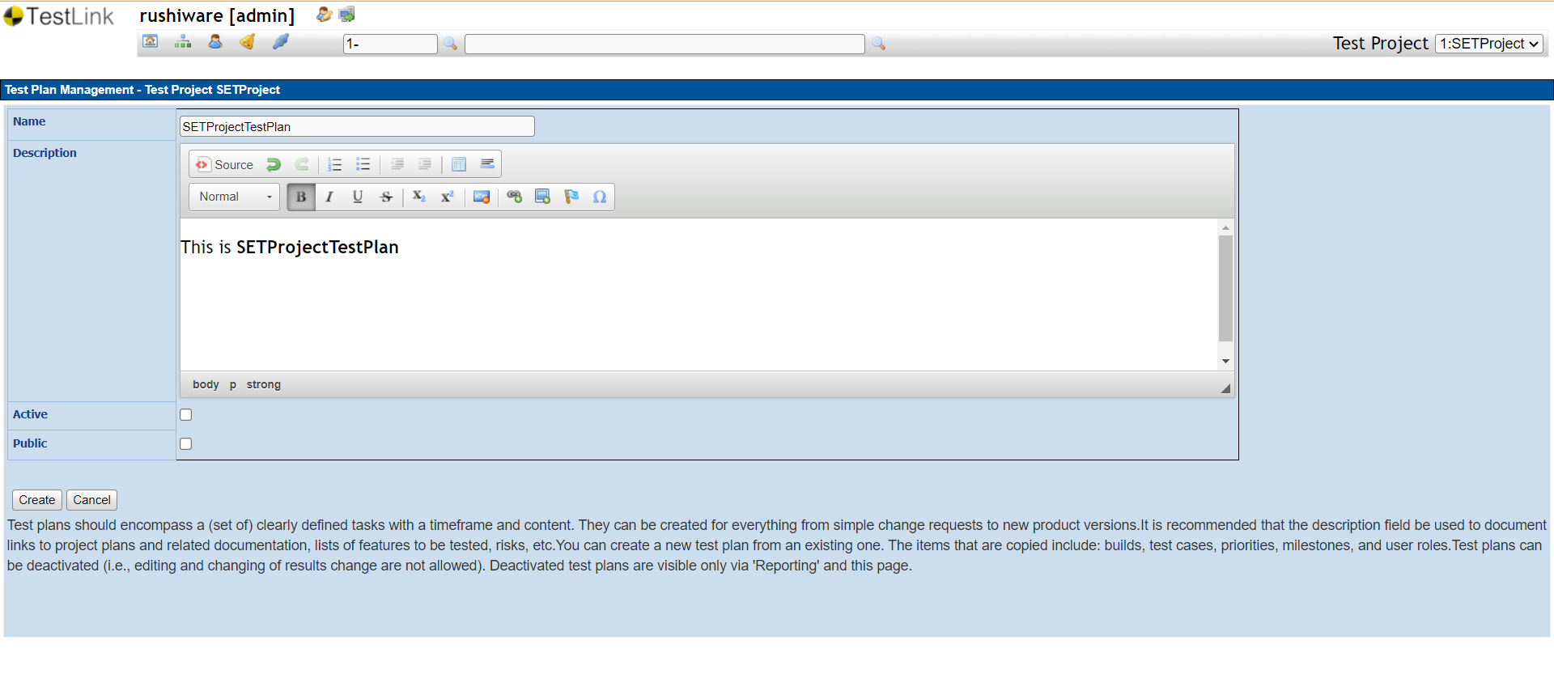

**c. Create a build as SETProjectBuild**

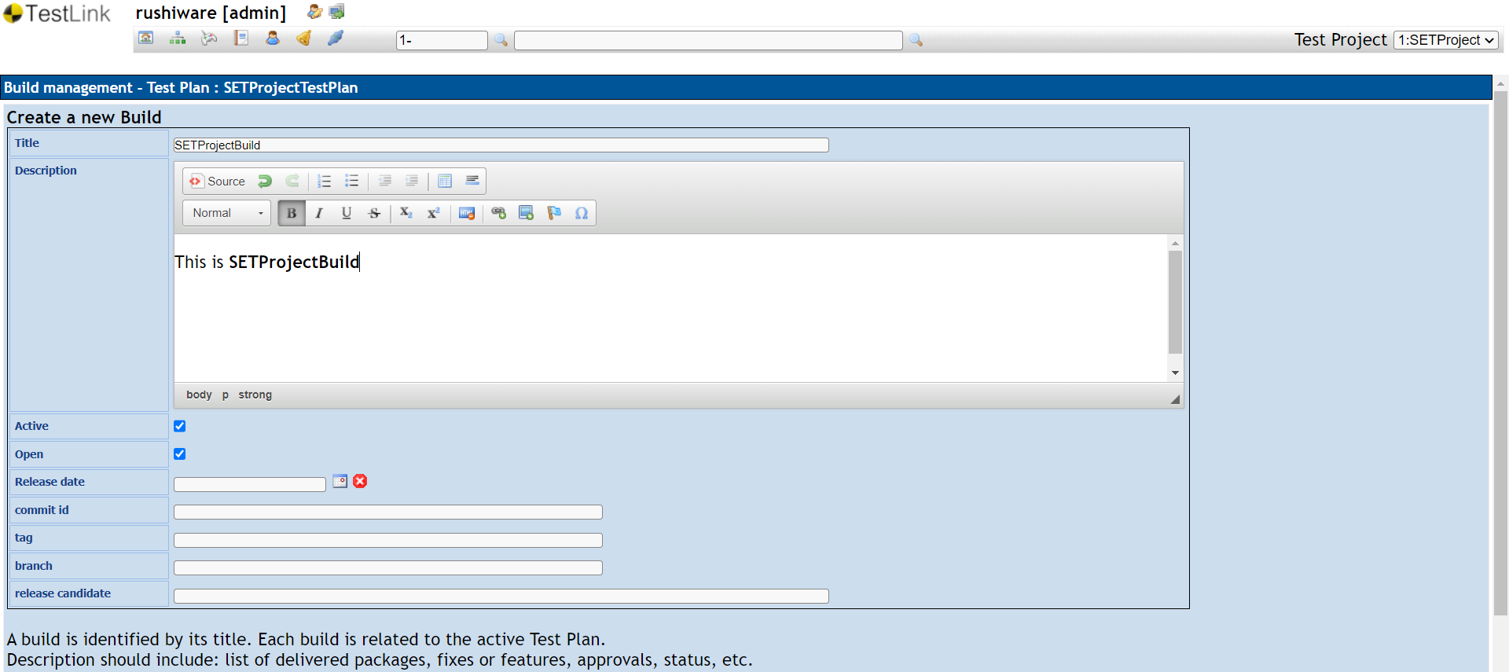

**d. Create test suite as Test Suite 1 under SETProject**

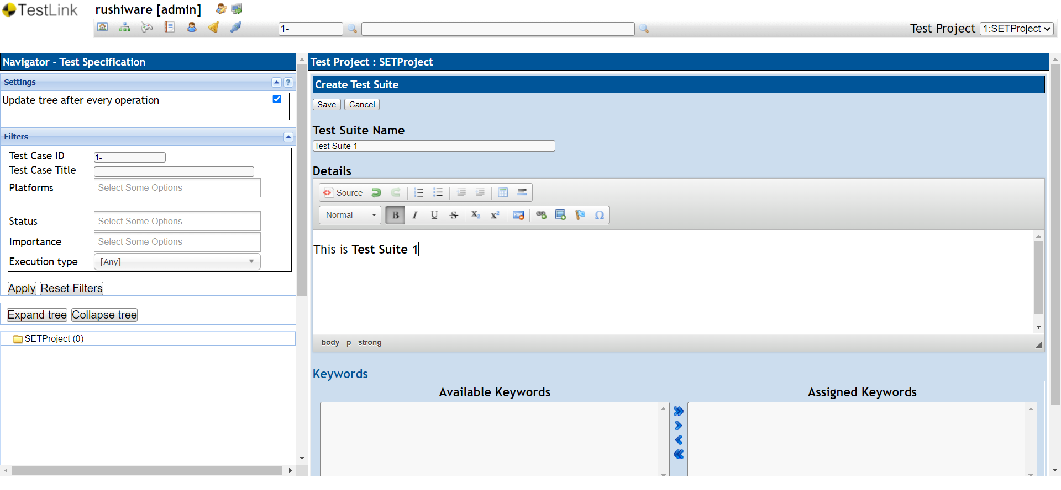

**e. Create Test cases in TestLink Tool**

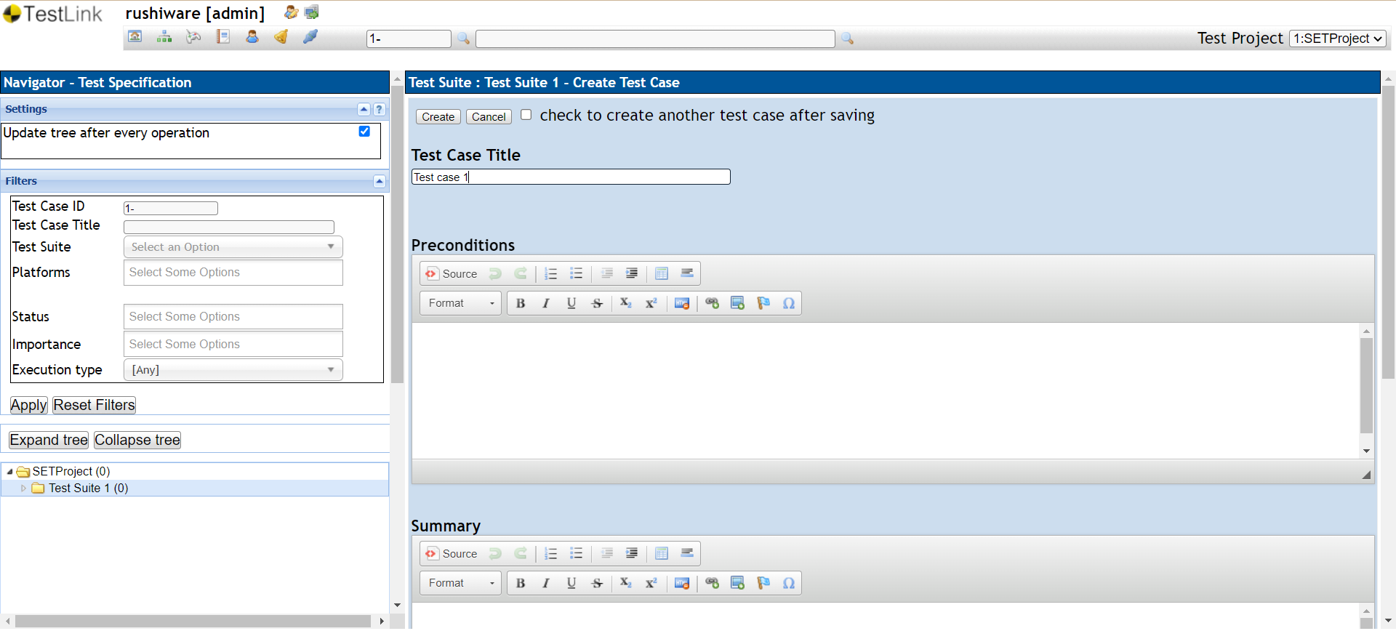

**f. Assign created Test Cases to the test plan SETProjectTestPlan**

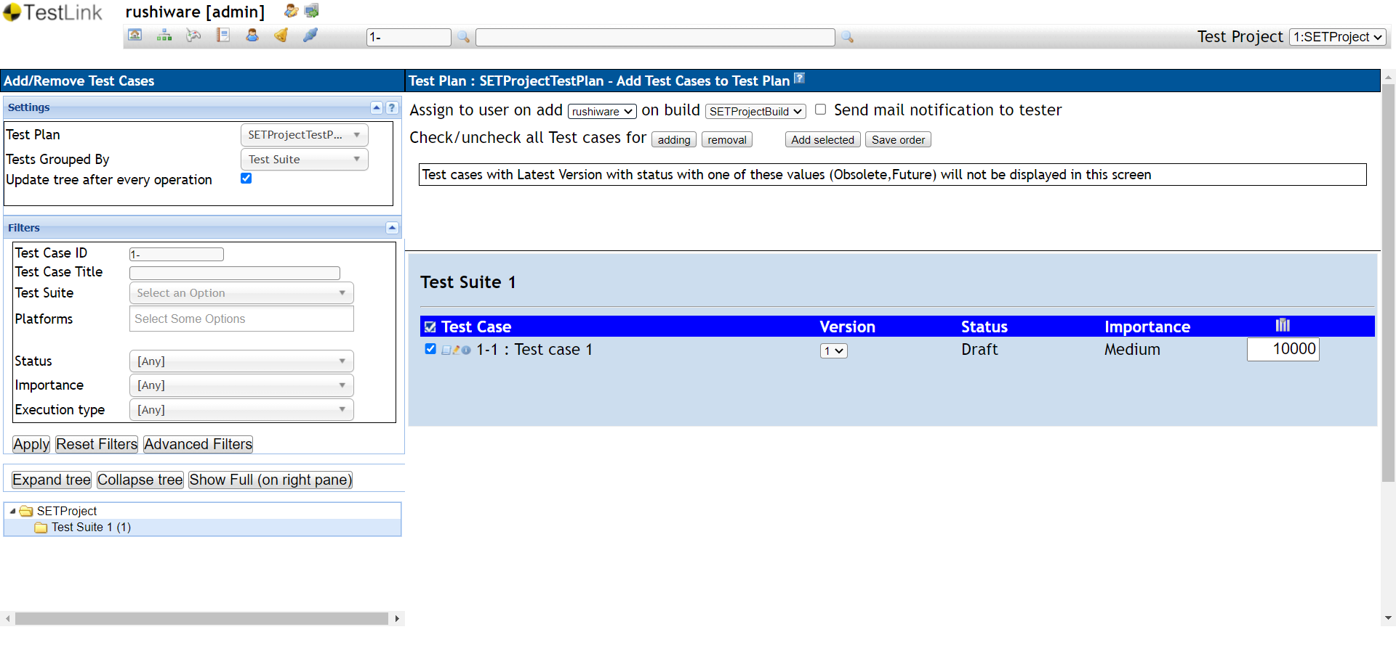

**g. Create different roles as given below in the TestLink**

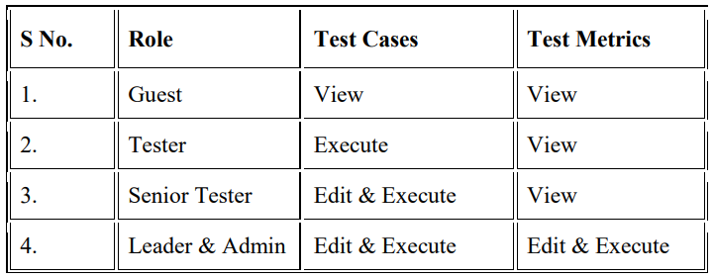

**Guest:**

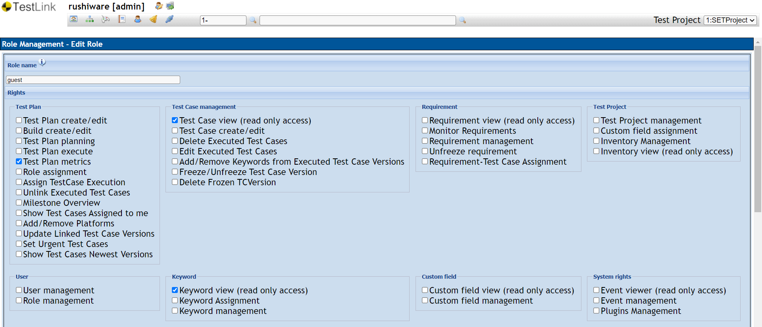

**Tester:**

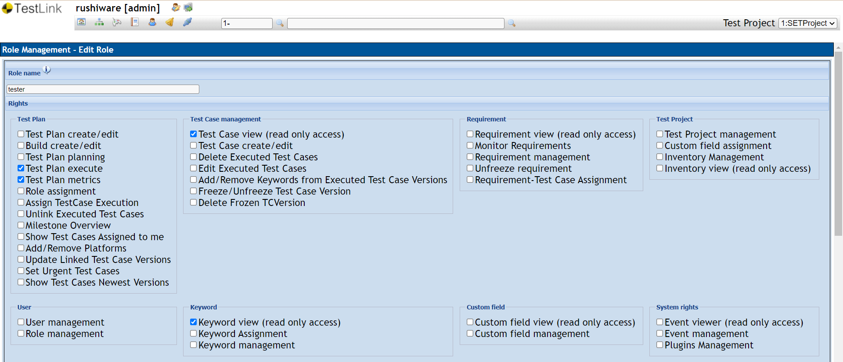

**Senior Tester:**

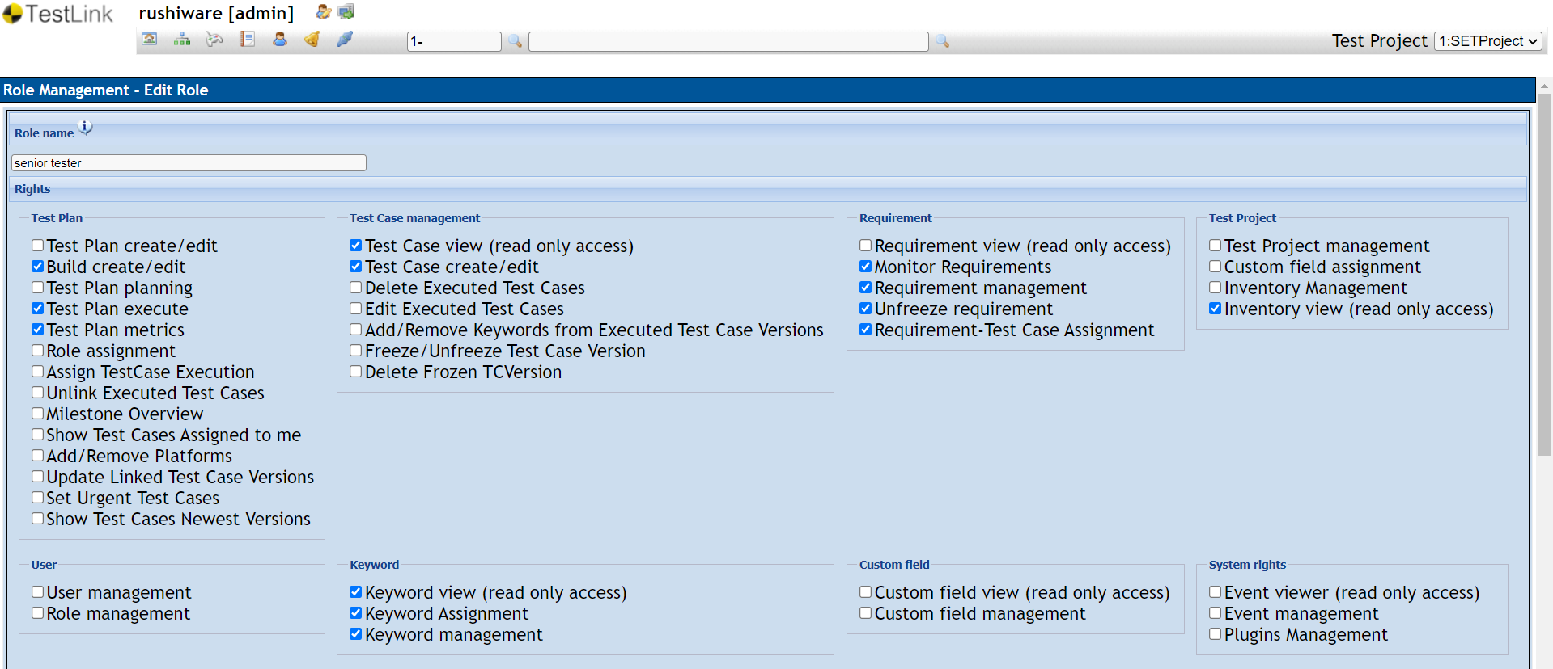

**Leader:**

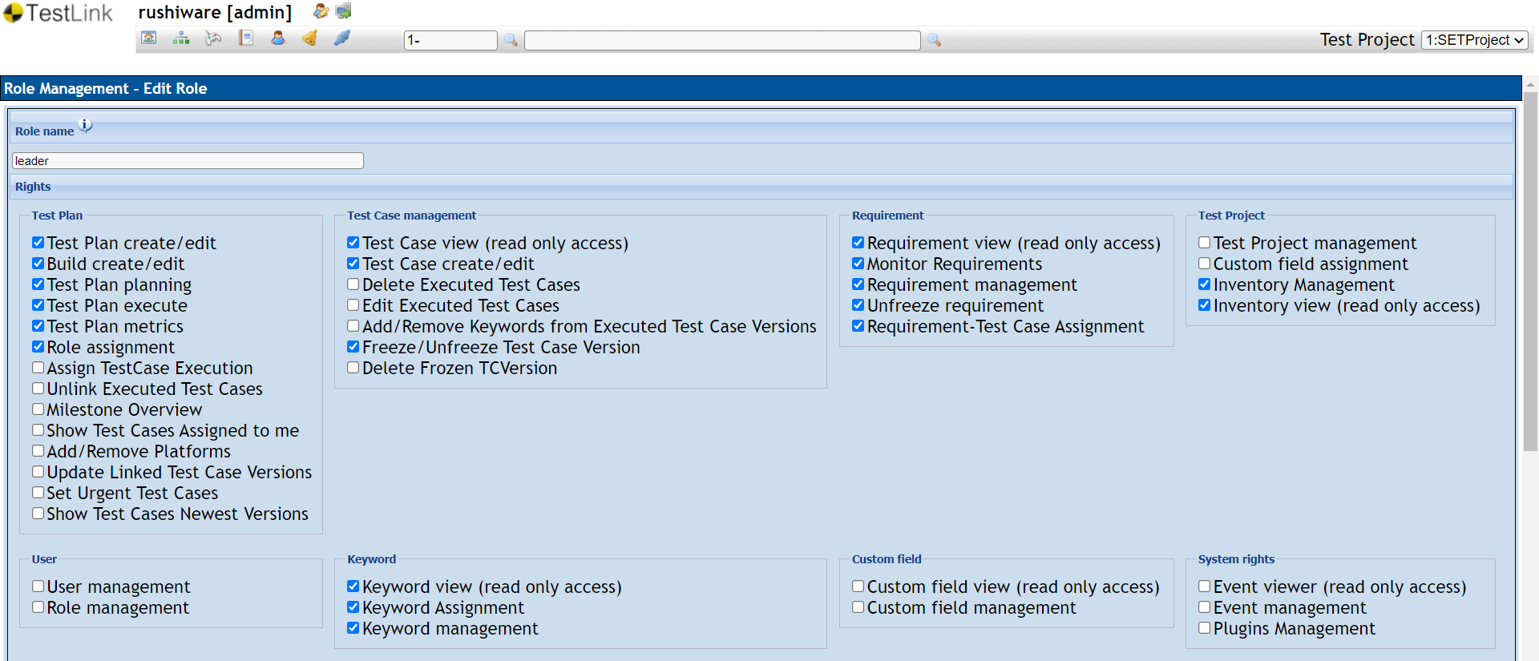

**Admin:**

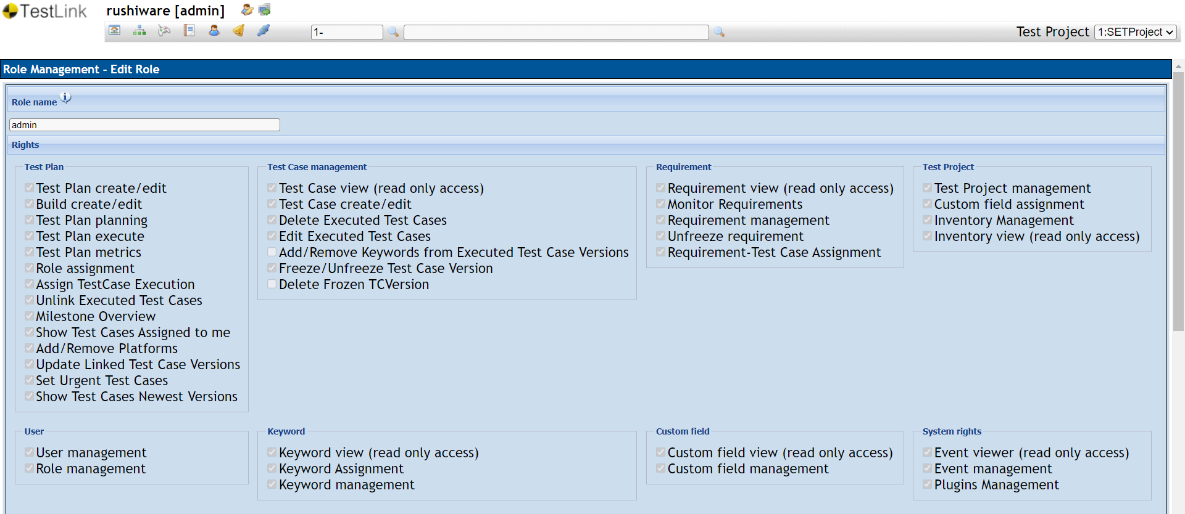

**h. Write a requirements in TestLink**

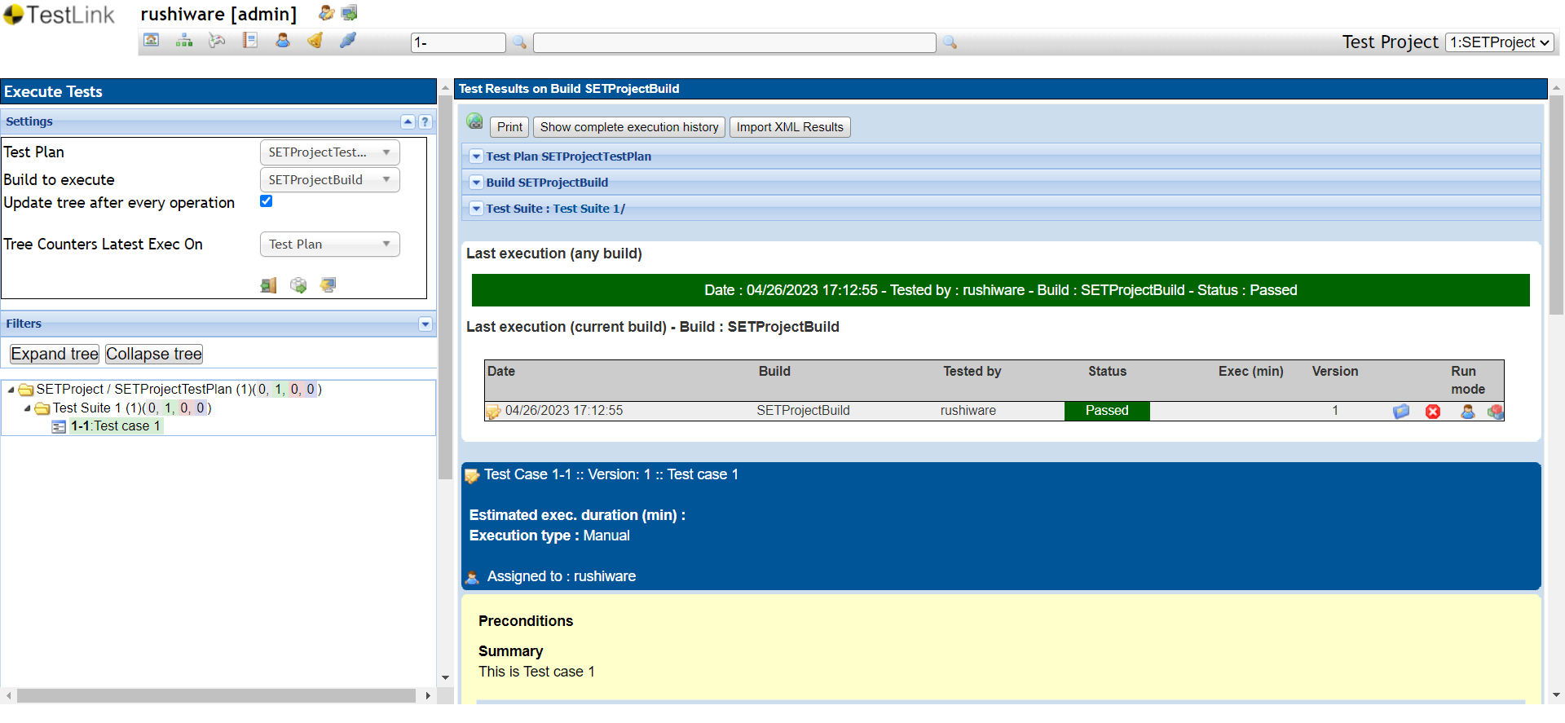

**i. Execute test cases**



**j. Generate a test report in excel format**

